Robert David Steele has worked in the intelligence (decision-support), information technology, and human networking space since 1976 – 38 years in 2014. Today he is the primary global proponent for Open Source Everything (OSE). Robert is the most published intelligence reformer in the English language, and a serial pioneer who has led innovation across the Central Intelligence Agency, the US Marine Corps, the North Atlantic Treaty Organization, the US Special Operations Command, and foreign agencies including the United Nations and selected countries in South America.
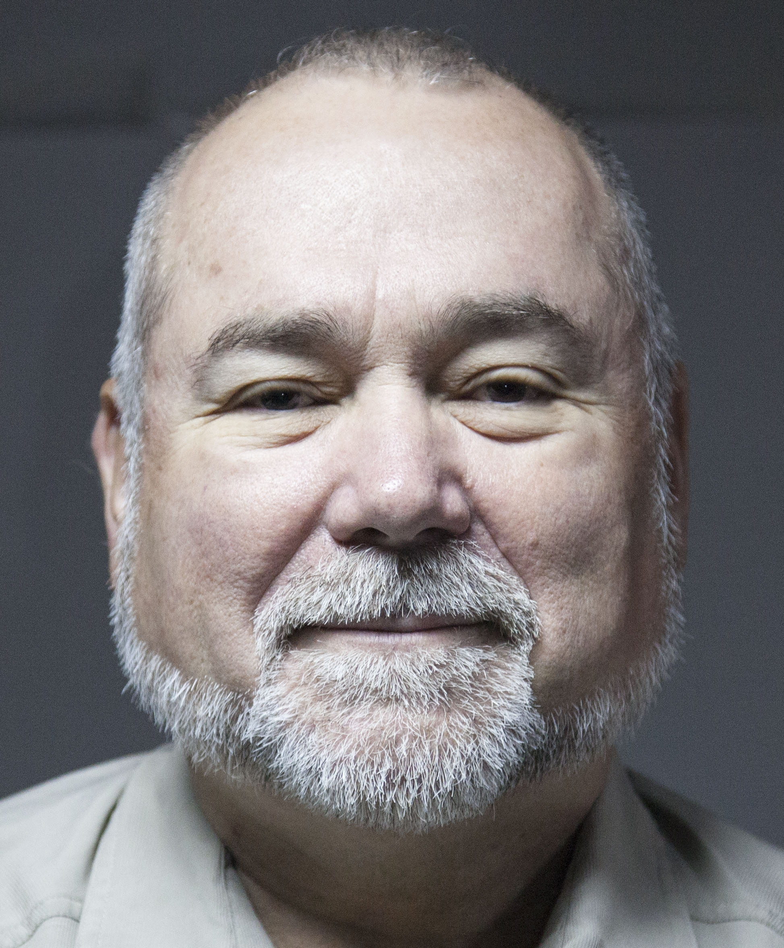
From 1988-1994 he was the principle founding proponent for Open Source Intelligence (OSINT) and one of three co-founders with Winn Schwartau of the first Information Warfare Conference, the first to clearly identify all of the cyber-vulnerabilities across the emerging Internet including all existing Supervisory Control and Data Acquisition (SCADA) networks. He has generally been 25 years ahead of industrial best practices.
A global strategist, innovator and educator by nature, Robert has taught over 7,500 mid-career professionals from across 66 countries, and has an internationally-recognized brand synonymous with transparency, truth, and trust. He has appeared in multiple films (English, French, German), spoken across over 20 countries, and been profiled by Alvin Toffler and Bruce Sterling, among others. He is a recurring invited participant in the Silicon Valley Hackers Conference started by Stewart Brand, and opened Hackers on Planet Earth in 1994, speaking at every event since. He is reputed to be admired by Anonymous and LutzSec on the basis of his Gnomedex keytone in 2007.
Robert’s areas of expertise span all aspects of information collection, processing, analysis, and dissemination, with deep knowledge in the areas of collection management, all-source machine-speed fusion, computer-assisted analysis, social and human network exploitation in near-real-time, and advanced analytics. He is a critic of big data myths and mis-practice, and a leading proponent for multinational information-sharing and sense-making across all boundaries. Among his specializations are the integration of humans and sensors from across the eight information tribes (academic, civil society, commerce, government, law enforcement, media, military, non-government/non-profit), and the integration of true cost economics (supply intelligence), holistic analytics (demand intelligence), and open source everything (engineering intelligence). His long-standing motto is “Information costs money, intelligence makes money.”
Since 2006 Robert has been focused on an accredited non-profit, Earth Intelligence Network (EIN). He funded 23 others, including Medard Gabel (co-creator with Buckminster Fuller of the analog World Game), in designing an integrated platform centered on an EarthGame and able to connect all individuals with all relevant information – including true cost information such as virtual water, fuel, toxins, and child labor ingredients – so as to restore public agency with voice and vote. Most recently he has led the design of an Open Source Everything Innovation Hub for a leading university in the United Kingdom, and is in discussion with a few universities about similar endeavors in those countries. Books published in this period include The Open Source Everything Manifesto: Transparency, Truth, & Trust (a best-seller at Amazon), Intelligence for Earth: Clarity, Diversity, Integrity, & Sustainability, and Collective Intelligence: Creating a Prosperous World at Peace.
From 1993 to 2010 Robert managed Open Source Solutions, Inc. (OSS) a Virginia C Corporation working exclusively for the US Special Operations Command (USSOCOM) and other elements of the US Department of Defense (DoD). In this capacity he pioneered modern commercial intelligence, supervising ad hoc teams operating in 29 languages normally and up to 183 as needed. He wrote the Open Source Intelligence (OSINT) handbooks for DoD, the North Atlantic Treaty Organization, and USSOCOM, all the while training – and drawing out – over 7,500 mid-career professionals from across 66 countries. Books published in this period include Information Operations, The Smart Nation Act, Peacekeeping Intelligence, The New Craft of Intelligence, and On Intelligence. The latter two books are honored with Forewords from past and serving chairman of the Senate Select Committee on Intelligence, Senator David Boren (D-OK) and Senator Pat Roberts (R-KS). In 1995 he provided invited testimony to the Aspin-Brown Commission, defeating the entire US secret world in an overnight exercise on Burundi, and in 1996 testified to the Moynihan Commission on Secrecy. He is an authority on what we are doing wrong and what we can do to get it right across the fundamentals – source collection, fusion processing, human-machine analytics, and timely pointed decision-support.
Joining the United States Marine Corps (USMC) as an infantry officer in 1976, Robert was quickly elevated, while still a Second Lieutenant, to a field-grade position, S-1/Adjutant of a Battalion Landing Team. He completed four years of active duty as S-/1/Adjutant of Marine Corps Depot San Diego (a division equivalent) and then transferred into the Reserve as an intelligence officer in 1979. As a Reserve officer he served at the Service level where he was a co-author of the Marine Corps Master Intelligence Plan (MCMIP), and specialized in critical reviews of the Theater Intelligence Architecture Plans (TIAP). In 1988 he became the second-ranking civilian in Marine Corps intelligence, responsible for creating the Marine Corps Intelligence Activity (MCIA). He led open source innovation and analytic modeling that resulted in strategic generalizations profoundly important to hundred billion dollar acquisition programs. In this capacity he also led the reform wing of the US secret world, serving on the Foreign Intelligence Requirements and Capabilities Plan Committee, the Information Handling Committee, and the Advanced Processing and Analysis Steering Group, a committee of which he was a co-founder. He left his civilian position to found OSS.Net as a means of advancing innovation.
Robert was competitively selected to join the Central Intelligence Agency (CIA) in 1979. Scoring in the top ten of his class, one of the largest at the time, he was immediately sent overseas as a Clandestine Operations Officer, and served a very unusual three back-to-back tours, the first in a combat zone. During this time he out-performed all others, being credited with five times the regional average in both the recruitment of human assets and the production of foreign intelligence reports. During his first tour abroad he managed a global media influence operation, something normally done by a large staff in Washington, D.C. He managed complex technical operations of every kind, one of which became a teaching standard, another resulting is an “ears only” briefing to President Ronald Reagan. During this time he drafted CIA’s first-ever Standard Operating Procedure for a (Clandestine) Field Station as well as the Guide to Managing the (Technical) Support Account. On his third tour he was one of the first officers ever assigned to chase terrorists full-time. Returning to Washington he was immediately assigned two full-time jobs with global responsibilities, one of them focusing on offensive counterintelligence. From there he was hand-picked to lead a new project in the Office of Information Technology focused on artificial and advanced information technology, helping lead innovation in both desk-top analytics and back-office machine speed data fusion and sense-making. He led the charge – and failed – to get everyone to understand that in addition to the prevailing date time stamps, geospatial attributes for every datum are essential to useful machine-speed data fusion. Blocked by those obsessed with secrecy over sharing, he was again hand-picked for the Director of Central Intelligence (DCI) unit managing all technical programs across the entire US intelligence community (imagery, signals, other). As a member of that unit, the Advanced Programs and Evaluation Group (APEG), he took the lead on future intelligence collection, processing, and analysis requirements and capabilities, serving on all the related national committees.
Professional training received by Robert has included all appropriate technical and management courses from CIA as well as the National Security Agency (NSA) and other US intelligence elements, with additional courses in advanced information technology including expert systems, natural language understanding, machine reading and learning, and geospatial visualization challenges and opportunities. He is a graduate of the CIA’s Mid-Career Course as well as the Marine Corps’ Command & Staff College, and received training in multiple aspects of security and personnel management while serving as an S-1/Adjutant in the US Marine Corps.
Robert’s education includes a Diploma from the Naval War College with emphasis on defense economics; a Master of Public Administration from the University of Oklahoma (4.0, elected to Pi Alpha Alpha) with a thesis on strategic information mis-management; a Master of Arts in International Relations from Lehigh University with a thesis creating an original complex analytic model for predicting revolution across all domains; an Arts Bachelor from Muhlenberg College with a thesis on multinational corporations and home/host country issues; and a Diploma from Singapore American High School, with honors.
He has been honored by Scotland Yard, the Department of Defense, the Department of State, and the Central Intelligence Agency, among others. He in turn has honored hundreds of others with his annual award of the Global Candle from 1992-2006, and in 2006, twelve lifetime achievement awards to OSINT pioneers.
Learn more at robertdavidsteele.com. A technical open letter is at http://tinyurl.com/2014-Open-Letter.
A post on human factors is here: http://www.phibetaiota.net/2015/05/round-up-the-human-factor/.
Below are four of his strategic innovation graphics.
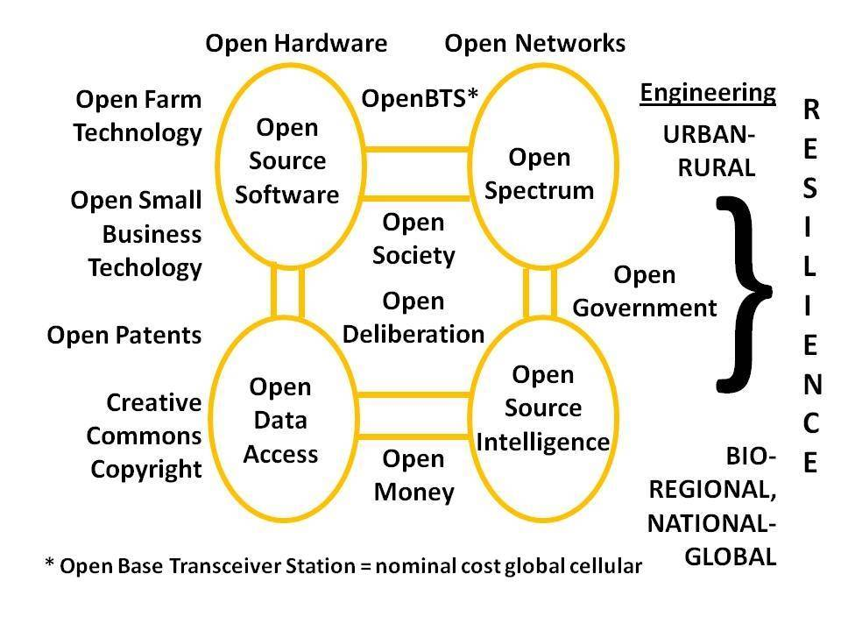 | 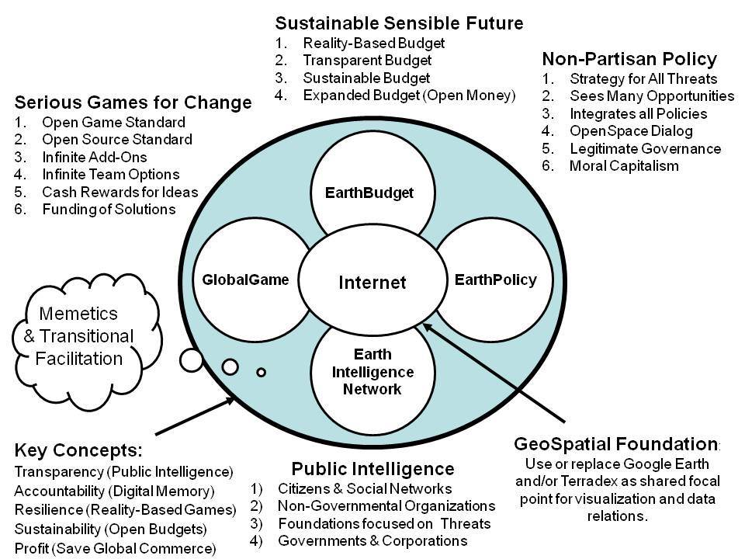
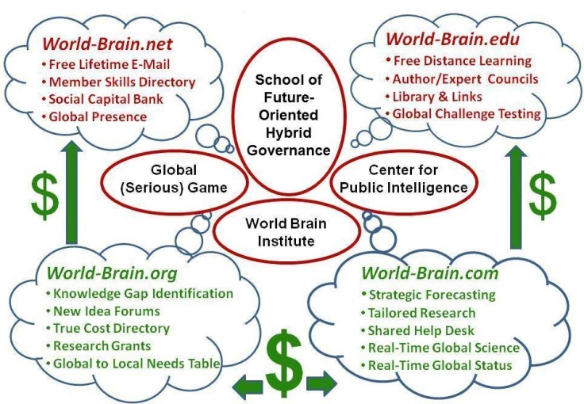 | 