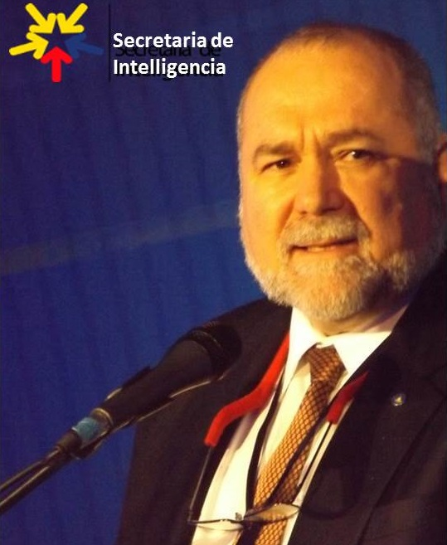
Robert David Steele is a champion for Peace Intelligence who has sought since 1988 to redirect the craft of intelligence (decision-support) away from spies and secrecy enabling war and waste, toward open sources and methods favorable to peace and prosperity.
Most recently he has lectured in Denmark and Norway on the need for creating a Nordic Peace Intelligence Centre and network for multinational information-sharing and sense-making that relies primarily but not exclusively on Open Source Intelligence (OSINT), the modern domain of which he is the undisputed pioneer. He is the author of all of the major OSINT Handbooks (US Defense Intelligence Agency, North Atlantic Treaty Organization, US Special Operations Forces) and believes the time has come for the Nordics to update and advance the craft of intelligence so as to address the illegal immigrants and other emerging threats that he first forecast from 1989 onwards.
In the past year he has outlined how an Open Source (Technologies) Agency can lead to the achievement of the UN Sustainable Development Goals (SDG) within a decade or two at a cost of less than 10% of the prevailing industrial-donor paradigm, by integrating holistic analytics, true cost economics, and Open Source Everything Engineering (OSEE). Pre-approved by the Office of Management and Budget (OMB) at a final annual budget of $2 billion a year, he has been blocked from reaching the Vice President of the United States and the Secretaries of Defense and State. If they were to read his Memorandum, this could lead to funding helpful to a Nordic, EU, and NATO implementation of his ideas for peace intelligence.
Since 2006 he has led and funded an educational non-profit, Earth Intelligence Network (EIN), where a team of 24 volunteers created a model for achieving local to global self-governance by making it possible for all individuals to have access to all information on all issues, achieving completely democracy. His three most recent books are COLLECTIVE INTELLIGENCE: Creating a Prosperous World at Peace (2008); INTELLIGENCE FOR EARTH: Clarity, Diversity, Integrity, & Sustainability (2010); and THE OPEN SOURCE EVERYTHING MANIFESTO: Transparency, Truth, & Trust (2012).
He is the originator of the term “information peacekeeping” and published the first major book on open source intelligence in the public interest (including a chapter on “The New Rules for the New Craft of Intelligence”) and the first major book on peacekeeping intelligence, one that stood on display in the lobby of the United Nations (UN) at 1 UN Plaza for over two years.
His first two books, ON INTELLIGENCE: Spies and Secrecy in an Open World (2000) and THE NEW CRAFT OF INTELLIGENCE: Personal, Public, & Political – Citizen’s Action Handbook for Fighting Terrorism, Genocide, Disease, Toxic Bombs, & Corruption (2002) were honored with Forewords by U.S. Senators themselves past or current Chairmen of the U.S. Senate Select Committee on Intelligence (SSCI). He predicted the illegal immigrant “break-out” toward Europe in his second book, and was a strong public and evidence-based opponent of the elective wars of the 1990’s that have created a swath of destruction from Afghanistan through Iraq and Libya to Syria and toward Niger and Nigeria, leading to the illegal immigrant threat to Europe that is certain to become worse.
His personal web site is http://robertdavidsteele.com; most of his publications can be accessed there at no cost. Three other educational websites that he has created can be accessed from there as well.
ROBERT DAVID STEELE – SUMMARY STATEMENT
Robert David Steele has sought since 1988 to redirect the craft of intelligence (decision-support) away from spies and secrecy enabling war and waste, toward open sources and methods favorable to peace and prosperity. He advocates strong counterintelligence and precision secrecy in context.
Biographic Synopsis: Robert David Steele was born of a Colombian mother naturalized as a US citizen, and a US-born father, on 16 July 1952 in New York. He is 63 years old as of today. As the son of an oil engineer, he grew up in the Caribbean, South America, and Asia, including four years in Viet-Nam from 1963 to 1967 (age 11-14). He graduated with honors from the Singapore American School in 1970. He earned an AB in Political Science from Muhlenberg College in 1974, with a senior thesis on Multinational Corporations: Home-Host Country Issues; and an MA in International Relations from Lehigh University in 1976 with a thesis on Internal War that created an original comprehensive matrix for predicting revolution on the basis of injustice across political-legal, socio-economic, ideo-cultural, techno-demographic, and natural-geographic domains. Rejecting a job offer from Lloyd’s Bank of London (New York City), he joined the US Marine Corps, serving four years active duty and sixteen years in the reserve, from 1976-1996. In 1978 he applied to join the Central Intelligence Agency (CIA) and was joined to the CIA in 1979, serving nine years as a clandestine case officer or operations officer, including three sequential tours overseas in South America, one of them as one of the first two CIA officers assigned terrorism as a full-time target. Returning to Washington he served three tours, respectively in counterintelligence, advanced information technology, and future satellite operations, providing staff oversight of the technical agencies then still under the Director of Central Intelligence (DCI). While serving as a full-time officer with the CIA he completed an MPA (Public Administration) with the University of Oklahoma in 1987 via its extension course taught by traveling faculty, with a thesis on Strategic Information (Mis) Management. On the basis of his extensive intelligence experience including concurrent assignments as a reserve military officer serving at the national and theater levels, he was invited by the Marine Corps to resign from the CIA and become the second-ranking civilian in Marine Corps Intelligence, the senior civilian responsible for creating the Marine Corps Intelligence Activity (MCIA) from 1988 to 1993. In this capacity he devised a new strategic analytic model seeking to radically enhance the ability of intelligence (decision-support) to support strategy, policy, acquisition, and operations. He designed and led the study, Overview of Planning and Programming Factors for Expeditionary Operations in the Third World (Marine Corps Combat Development Command, March 1990). It was this experience that led to his realization that secret intelligence is largely corrupt and useless – a finding confirmed by General Anthony Zinni, USMC two decades later – and that Open Source Intelligence (OSINT) was the necessary common discipline for helping governments and other institutions including corporations and non-government organizations (NGO) achieve peace and prosperity. In the same year he completed the Naval War College with a professional certificate in Defense Studies. In 1989 – before the complete study was published – he ghost-wrote an article for the Commandant of the Marine Corps, then General Al Gray, identifying emerging non-state actors as the threat of the future, and pointing out that intelligence must make the case for “peaceful preventive measures” if we were to avoid strategic failure in the future. In 1992 he founded an international conference and for-profit company (Open Source Solutions, Inc.) teaching 7,500 mid-career officers from over 66 countries how to do Open Source Intelligence (OSINT), but failed to overcome the embedded military-industrial complex in all these nations. Since 2006 he has led and funded an educational non-profit, Earth Intelligence Network (EIN), where a team of 24 volunteers created a model for achieving local to global self-governance by making it possible for all individuals to have access to all information on all issues, achieving completely democracy. In passing, he is a top Amazon reviewer for non-fiction, reading in 98 categories, with 2,082 reviews still on file. He is married (28 years) with three grown children.
Graphic Depictions: Below are six graphics that illuminate his thinking.
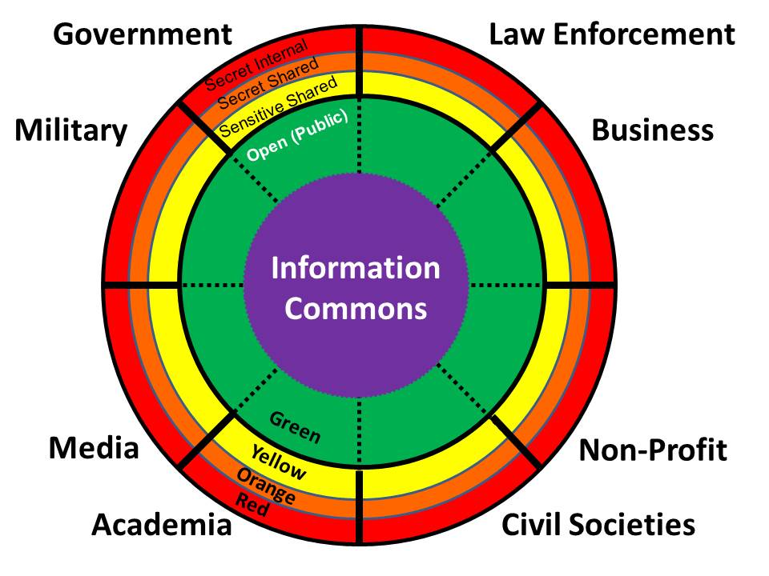 | 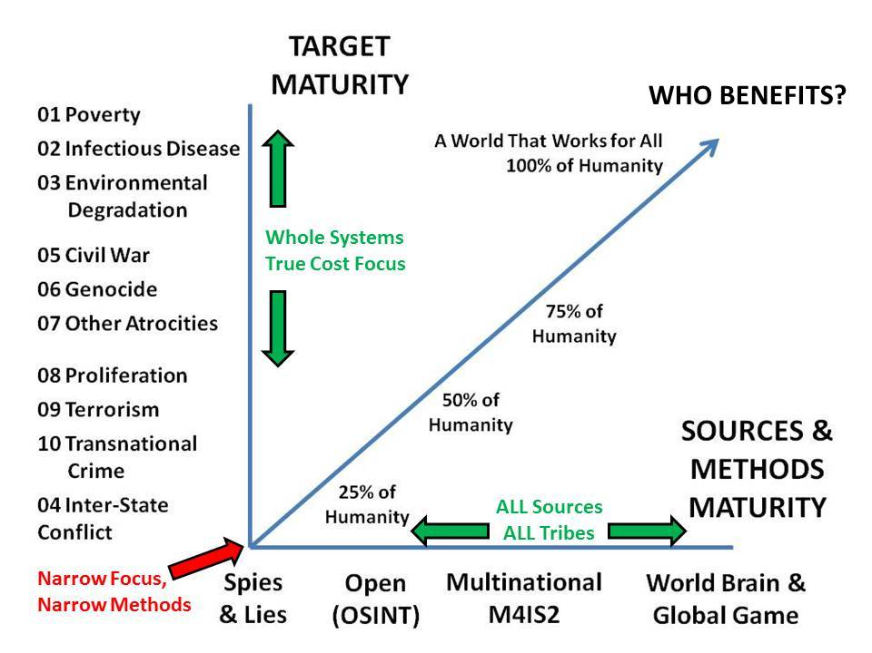
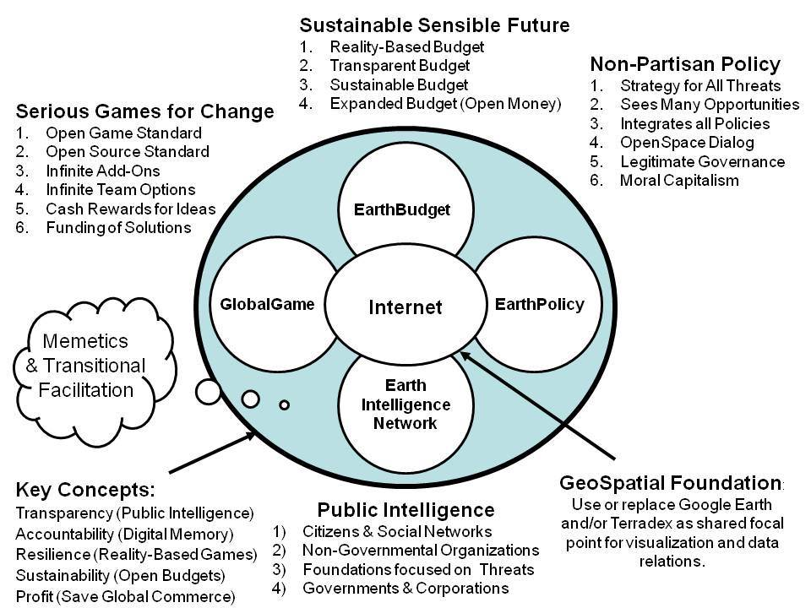 | 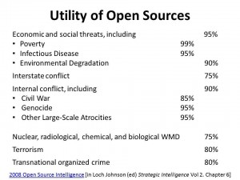
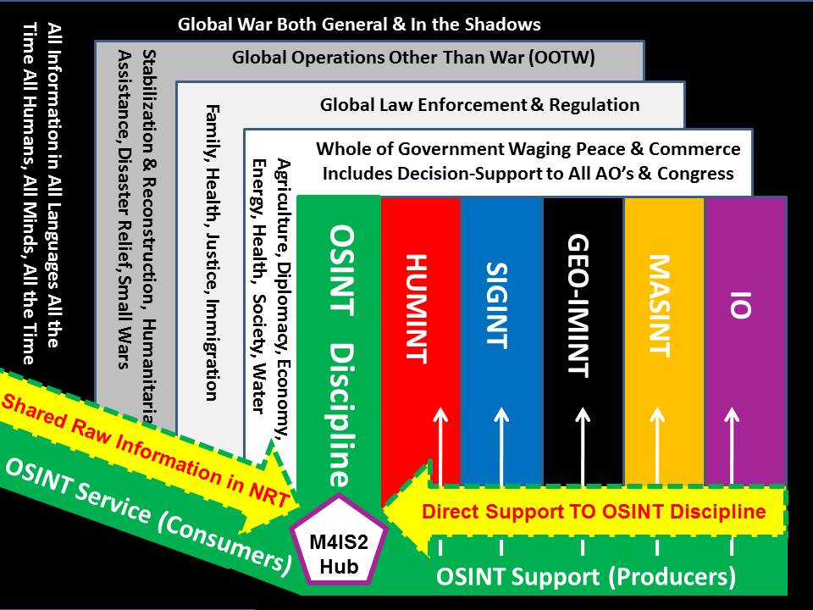 | 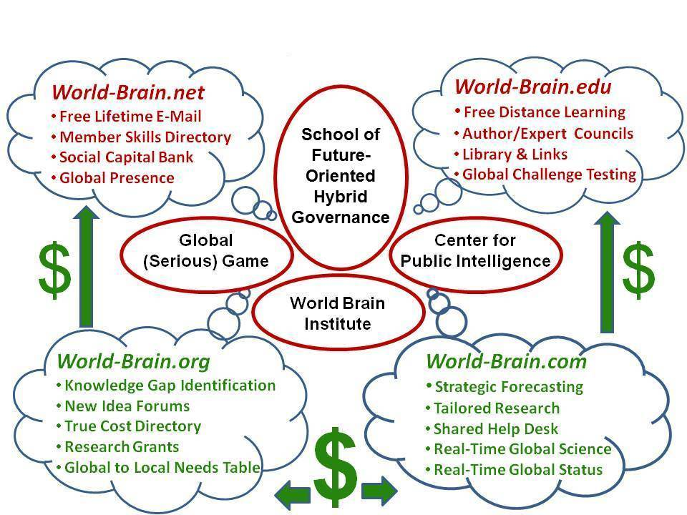

Seminal Works: Among his seminal works are eight printed books on intelligence and information operations, and many articles, briefings, chapters, lectures, and testimony to Congressional and Presidential Commissions. Below is a selected chronology of his work on peace intelligence not including the books already mentioned. More information is at http://robertdavidsteele.com.
1989: Gray, Al (Ghost-Written by Robert Steele), “Global Intelligence Challenges in the 1990’s,” American Intelligence Journal, Winter 1989-1990, pp. 37-41.
1990: Steele, Robert. “Intelligence in the 1990’s: Recasting National Security in a Changing World,” American Intelligence Journal, Summer/Fall 1990, pp. 29-36.
1992: Steele, Robert. “Information Concepts & Doctrine for the Future,” McLean, VA: Proceedings of the First International Symposium on National Security & National Competitiveness: Open Source Solutions, December 1, 1992.
1996: Steele, Robert. “SPECIAL FEATURE: Creating a Smart Nation–Strategy, Policy, Intelligence, and Information,” Government Information Quarterly, pp. 159-173; and Steele, Robert. “Information Peacekeeping: Innovative Policy Options,” Proceedings, Fifth International Symposium on Global Security & Global Competitiveness: Open Source Solutions,” Vol II, pp. 255-267.
1997: Steele, Robert. “Virtual Intelligence: Conflict Avoidance and Resolution Through Information Peacekeeping,” Proceedings, Conference on Virtual Diplomacy, April 1-2, 1997.
2004: Steele, Robert. “Information Peacekeeping & The Future of Intelligence,” International Journal of Intelligence and Counterintelligence, 17/2 265-285, Summer 2004.
2006: Steele, Robert. “Peacekeeping Intelligence & Information Peacekeeping, ” International Journal of Intelligence and Counterintelligence, 19/3 187-193, Spring 2006.
2009: Steele, Robert. “The Ultimate Hack: Re-Inventing Intelligence to Re-Engineer Earth,” Odense, DK, October 27-28 2009 and Steele, Robert. “The Ultimate Hack: Re-Inventing Intelligence to Re-Engineer Earth,” Vancouver, CA: University of British Columbia, Faculty of Advanced Engineering, Workshop on Complex Analysis of Large-Scale Systems, March 17, 2009, published as Steele, Robert. “The Ultimate Hack: Re-Inventing Intelligence to Re-Engineer Earth,” in U. K. Wiil (ed.), Counterterrorism and Open-Source Intelligence, Lecture Notes in Social Networks 2, Springer-Verlag/Wien, 2011.
2012: Steele, Robert. “Reflexivity as Integrity: Toward Earth/Life 4.0,” Washington, DC: Washington Academy of Sciences, March 31, 2012 and Steele, Robert. “Proposal for a World Brain Institute and Development of a Global Game,” Humanity Plus Magazine, December 26, 2012.
2013: Steele, Robert. “Healing the Americas with an Open Source Agency — and Integrity / Dicho Sobre la Curacion de las Americas con un Agencia de Todo Abierto — y la Integridad,” Washington, DC: Inter-Americas Defense Board (IADB), January 26, 2013 and Steele, Robert. “The Evolving Craft of Intelligence,” in Robert Dover, Michael Goodman, and Claudia Hillebrand (eds.). Routledge Companion to Intelligence Studies, Oxford, UK: Routledge, July 31, 2013.
2014: Steele, Robert, “Applied Collective Intelligence: Human-Centric Holistic Analytics, True Cost Economics, and Open Source Everything,” Spanda Journal, December 20-14, Vol. 2, pp 127-137.
2015: Steele, Robert. “Memorandum for the Vice President, Open Source (Technologies) Agency, Digital Deserts, & Global Stabilization,” Oakton, VA: Earth Intelligence Network, October 8, 2015 and Robert Steele: An American Grand Strategy, Phi Beta Iota Public Intelligence Blog, 31 October 2015.
2016: Steele, Robert. “Open Source Everything Engineering (OSEE) — a Nordic Manifesto,” Phi Beta Iota Public Intelligence Blog, April 15, 2016 – videos and other materials related to a Danish government invitation to lecture in Copenhagen are at http://tinyurl.com/2016-OSINT.
Forthcoming:
2016 Robert Steele for IEEE: Open Source Everything Engineering (OSEE) — Implications for the Future of Information Technology (IT); Robert Steele: New Chapter on Augmented Human Intelligence with Man-Machine Integrity; and Robert Steele: Reinventing the US Army by Closing All Overseas Bases, Building a 450-Ship Navy, Long-Haul Air Force, and Air-Mobile Army, while Cutting Pentagon Budget (and Flag Officers) in Half (US Army War College, Strategic Studies Institute).

